6.41: a) The initial and final (at the maximum distance) kinetic energy is zero, so the positive work done by the spring, 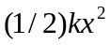, must be the opposite of the negative work done by gravity, 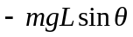, or
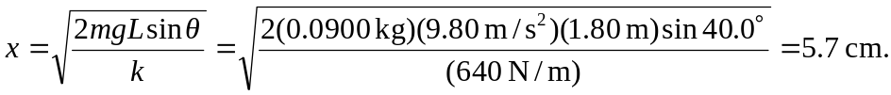
At this point the glider is no longer in contact with the spring. b) The intermediate calculation of the initial compression can be avoided by considering that between the point 0.80 m from the launch to the maximum distance, gravity does a negative amount of work given by , and so the kinetic energy of the glider at this point is 0.567 J. At this point the glider is no longer in contact with the spring.

